(University Logo)
InfiCompute: An Android Framework for Synchronized Computation with Cloud

A PROJECT REPORT

submitted by

Student Name 1 (Roll No.)
Student Name 2 (Roll No.)
Student Name 3 (Roll No.)

Department Computer Science and Engineering

College/University name
City with PIN Code
in collaboration with
SAP Labs, Bengaluru
April 2024
BONAFIDE CERTIFICATE

Certified that the mini-project titled “Topic Name” is the bonafide work of “Students names (with their roll no.s)”which is carried out under our mentoring.

-------------------------  SIGNATURE  INDUSTRY MENTOR  Mentor Name  Spend Engineering,  SAP Labs  Bengaluru,  Karnataka, India | -------------------------  SIGNATURE  ACADAMIC MENTOR  Prof. Name  Designation  Computer Science and Engineering  Institute Name  City Name with PIN Code

-------------------------  SIGNATURE  Srivatsan Santhanam  VICE PRESIDENT  Spend Engineering,  Head of Concur R&D,  SAP Labs  Bengaluru,  Karnataka, India | -------------------------  SIGNATURE  Name of HoD  HEAD OF THE DEPARTMENT  Professor  Computer Science and Engineering  Institute Name  City Name with PIN Code

Submitted for evaluation on _____________

ACKNOWLEDGEMENT
(Sample only; can be modified suitably)

We would like to express our deepest gratitude to our beloved Principal, Name of Principlal with his/her degree Degree, for his overwhelming support and encouragement on this project.
We extent our indebted to Mr. SRIVATSAN SANTHANAM, Vice President, Spend Engineering, Head of Concur R&D, SAP Labs India for the opportunity and support which was instrumental in the completion of this project.
We are greatly indebted to HoD Name with his/her degree Head of the Department, Computer Science and Engineering for her guidance and continuous support which was instrumental in the completion of this project.
We extend our thanks to our industry mentor, Mentor Name, SAP Labs, Bengaluru, India and academic mentor Name of the academic mentor with his/her degree and with their designation, Computer Science and Engineering for his technical support and constant supervision without which we could not have completed this project study.
Students name

ABSTRACT
Three paragraphs

Keywords: maximum six keywords

TABLE OF CONTENTS
CHAPTER NO TITLE PAGE NO
ABSTRACT iv
LIST OF TABLES viii
LIST OF FIGURES ix
LIST OF ABBREVIATIONS x
1 INTRODUCTION
1.1 PROJECT MOTIVATION 1
1.2 PROBLEM STATEMENT AND OBJECTIVES 3
1.3 SCOPE AND LIMITATIONS OF THE PROJECT 5
2 PROJECT ARCHITECTURE, DESIGN AND
IMPLEMENTATION
2.1 SYSTEM ARCHITECTURE 5
2.2 OVERVIEW OF THE DESIGN PROCESS 7
2.3 EXPLANATION OF THE ENGINEERING
PRINCIPLES USED IN THE DESIGN 8

  - DESCRIPTION OF THE STEPS TAKEN TO
IMPLEMENT THE PROJECT DESIGN 10

3 RESULTS AND ANALYSIS 20
3.1 VALIDATION PROCEDURES 21
3.2 TEST RESULTS 22
3.3 ANALYSIS OF RESULTS 23
4 LEARNING OUTCOMES 26
5 CONCLUSION AND RECOMMENDATIONS 35
REFERENCES
LIST OF TABLES
TABLE NO TITLE PAGENO
2.1 Configurations used for VM Instances in GCP 15
3.1 Application Runtimes using InfiCompute 18

LIST OF FIGURES
FIGURE NO TITLE PAGENO 1.1 Number of Smartphone users in India 2
1.2 Moore’s Law 3
1.3 Evolution of Cloud Computing 5
3.1 Node.js Asynchronous Execution 22
3.2 Web Socket Connection 23
3.3 Anbox Stack 24
3.4 Anbox Architecture 25
3.5 Features of GCP 26

LIST OF ABBREVIATIONS
(Should be arranged in Alphabetical order)
ADT Android Development Tools
AJAX Asynchronous Javascript and XML
API Application Programming Interface
CLI Command Line Interface
CPU Central Processing Unit
GCP Google Cloud Platform
GUI Graphical User Interface
HTTP Hypertext Transfer Protocol
IDE Integrated Development Environment
IP Internet Protocol
JS JavaScript
JSON JavaScript Object Notation
JWT JSON Web Token
WS Web Sockets
XML Xtensible Markup Language
CHAPTER 1
INTRODUCTION

1.1 PROJECT MOTIVATION
The developing number of challenges to confront as architects, engineers, and specialists nowadays.
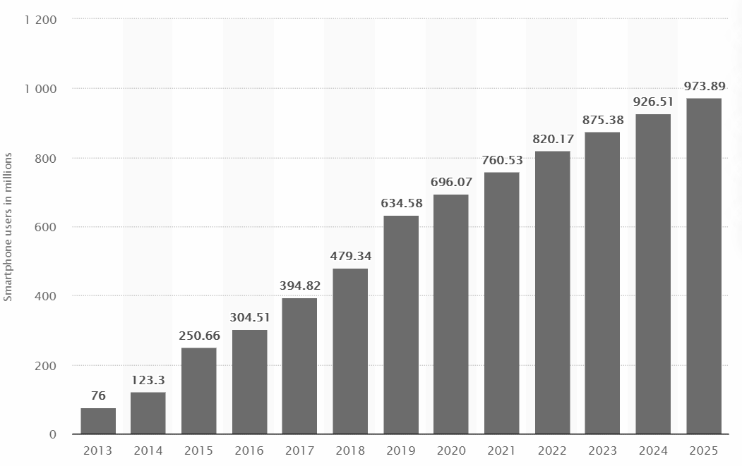
Figure 1.1 No. of Smartphone Users in India (2013 to 2020) with Forecast until 2025
Source Link (Sample Figure and Caption)
(All figures should be referred inside the report and sufficient explanation should be included)

From Figure 1.1 it can be observed that more computing power is generated than it is generated in the previous five years combined. The world now has more computing resources than one can efficiently use. However, this overabundance marks the start of something more than the finish.

1.2 PROBLEM STATEMENT AND OBJECTIVES

1.3 SCOPE AND LIMITATIONS OF THE PROJECT

CHAPTER 2
PROJECT ARCHITECTURE, DESIGN AND IMPLEMENTATION

2.1 SYSTEM ARCHITECTURE

………..
……….
2.2 OVERVIEW OF THE DESIGN PROCESS
The transition of resource-intensive computing functions to a different device such as a hardware accelerator or an external network, such as a cluster, grid, or cloud, is referred to as computation unlading. There are two main techniques under computation unlading, namely static decision and dynamic decision as shown in Figure 2.1.
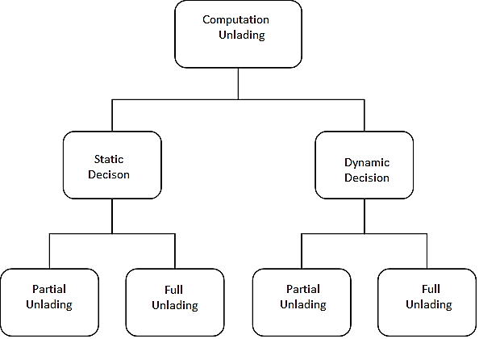
Figure 2.1 Unlading Techniques (Sample Figure)

2.3 EXPLANATION OF THE ENGINEERING PRINCIPLES USED IN
THE DESIGN
The Virtual Machine is booted with Ubuntu 18.04 and the various flavors used for the VM are shown in Table 5.1.
Table 5.1 Configurations used for VM Instances in GCP (Sample Table and Caption)
(All tables should be referred inside the report and proper interpretations and inferences should be included)

Machine type | Virtual CPUs | Memory | Price (USD) | Preemptible price (USD)
e2-highcpu-32 | 32 | 32 GB | $0.79488 | $23744
n1-highcpu-32 | 32 | 28.80 GB | $1.1335776 | $0.0149156
n2-highcpu-32 | 32 | 32 GB | $1.147136 | $0.27776
n2d-highcpu-32 | 32 | 32 GB | $0.998016 | $0.241504
c2-standard-30 | 30 | 120 GB | $1.5660 | $0.3790
a2-highgpu-2g | 24 | 170 GB | $7.34677 | $2.204031

2.4 DESCRIPTION OF THE STEPS TAKEN TO IMPLEMENT THE
PROJECT DESIGN

CHAPTER 3
RESULTS AND ANALYSIS

3.1 VALIDATION PROCEDURES

3.2 TEST RESULTS

sample screen shots may be included

Figure 3.1 Anbox in Ubuntu VM
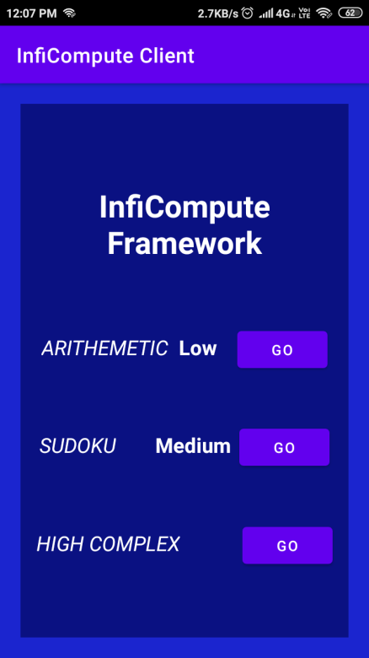
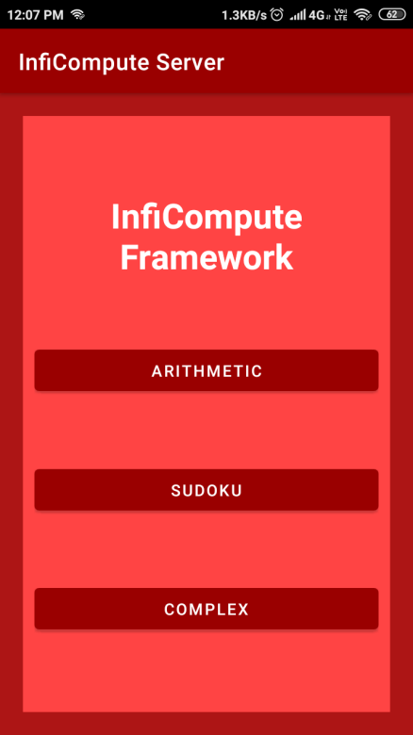

Figure 3.2 Dashboard for Client and Cloud Device
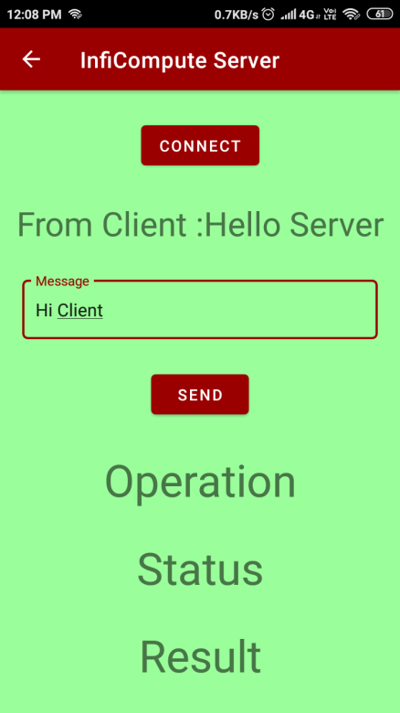
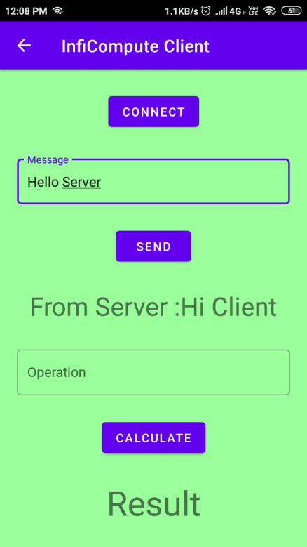

CHAPTER 4
LEARNING OUTCOMES

3.3 ANALYSIS OF RESULTS

CHAPTER 4
CONCLUSIONS AND FUTURE WORK
- Summary of the project objectives and achievements
- Discussion of any limitations or areas for improvement in the project design and implementation
- Recommendations for future research or development in the field

REFERENCES
(All references should be in IEEE format and cited inside the report)
List of all sources cited in the project report

- Sokol Kosta, Andrius Aucinas, Pan Hui, Richard Mortier, and Xinwen Zhang. (2012) “Think Air: Dynamic Resource Allocation and Parallel execution in the cloud for mobile code offloading”, IEEE Annual Joint Conference: INFOCOM, IEEE Computer and Communication Societies.
- Kai Lin, Sameer Pankaj, and Di Wang. (2018) “Task offloading and resource allocation for edge-of-things computing on smart healthcare systems”, Computers and Electrical engineering Journal, Volume 72.
- Weiwen Zhang, and Yonggang Wen. (2018) “Energy-Efficient Task Execution for Application as a General Topology in Mobile Cloud Computing”, IEEE Transactions on Cloud Computing, Volume: 6, Issue: 3, DOI: 10.1109/TCC.2015.2511727.
- Hyun Jung La, and Soo Dong Kim. (2014) “A Taxonomy of Offloading in Mobile Cloud Computing”, IEEE 7th International Conference on Service-Oriented Computing and Applications (SOCA).

